IBM ASSIGNMENT-1

NAME : HEMALATHA.MP

TEAM ID : PNT2022TMID26632

REGISTER NO : 212919106030

CIRCUIT LAYOUT :

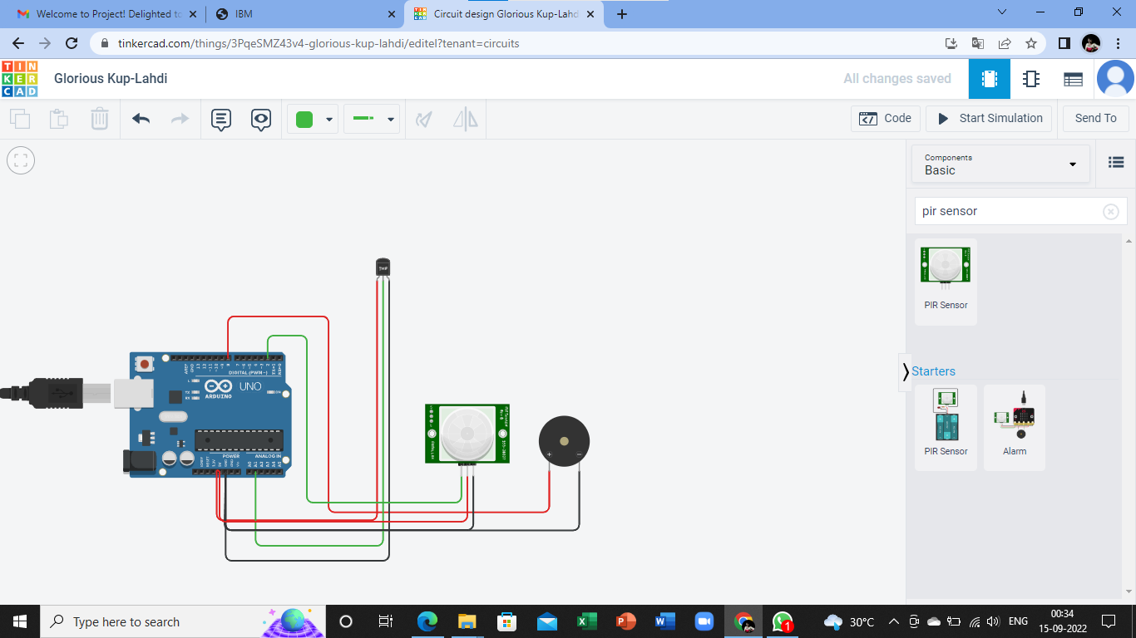

Coding :

void setup()

{

Serial.begin (9600);

pinMode(2, INPUT);

pinMode(12,OUTPUT);

pinMode(A3,INPUT);

}

void loop()

{

int motion = digitalRead(2);

if (motion==1){

Serial.println("Motion detected");

tone (12,20000);

delay(500);

}

else{

Serial.println("No Motion");

noTone(12);

}

{

double data=analogRead(A3);

double n=data/1024;

double volt=n\*5;

double off=volt-0.5;

double temperature=off\*100;

if (temperature>59.99){

Serial.print("Temperature data:");

Serial.println(temperature);

tone(12,10000);

delay(500);

}

else

Serial.print("Temperature data: ");

Serial.println(temperature);

noTone(12);

}

}

Output :

1).Passive Infrared Sensor :

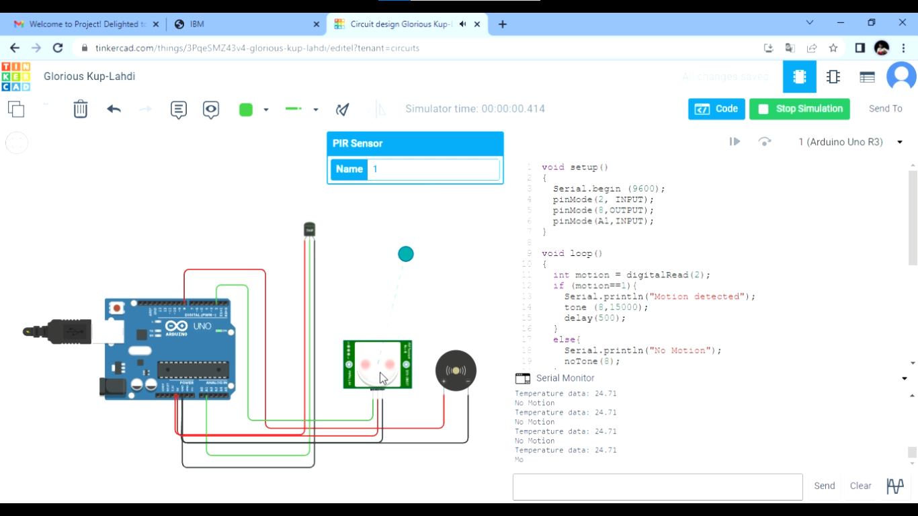

2).Temperature Sensor :

